BUSINESS PROBLEM FOR HOTEL BOOKINGS DATASET

In Recent Years , city hotel and Resort Hotels have seen high Cancellation Rates . Each Hotels are now dealing with Number of issues including Lower generation of revenue compare to previous years and less then ideal hotel room Use.

Consequently Lower Cancellation rates is both hotels’ primary goal in order to increase their efficiency to generating their revenue and For us to offer thorough business advice to address this issue.

The Analysis of Hotel Booking Cancellations as well as other factors that have no bearing on their business and yearly Revenue generation are the main topics of this report

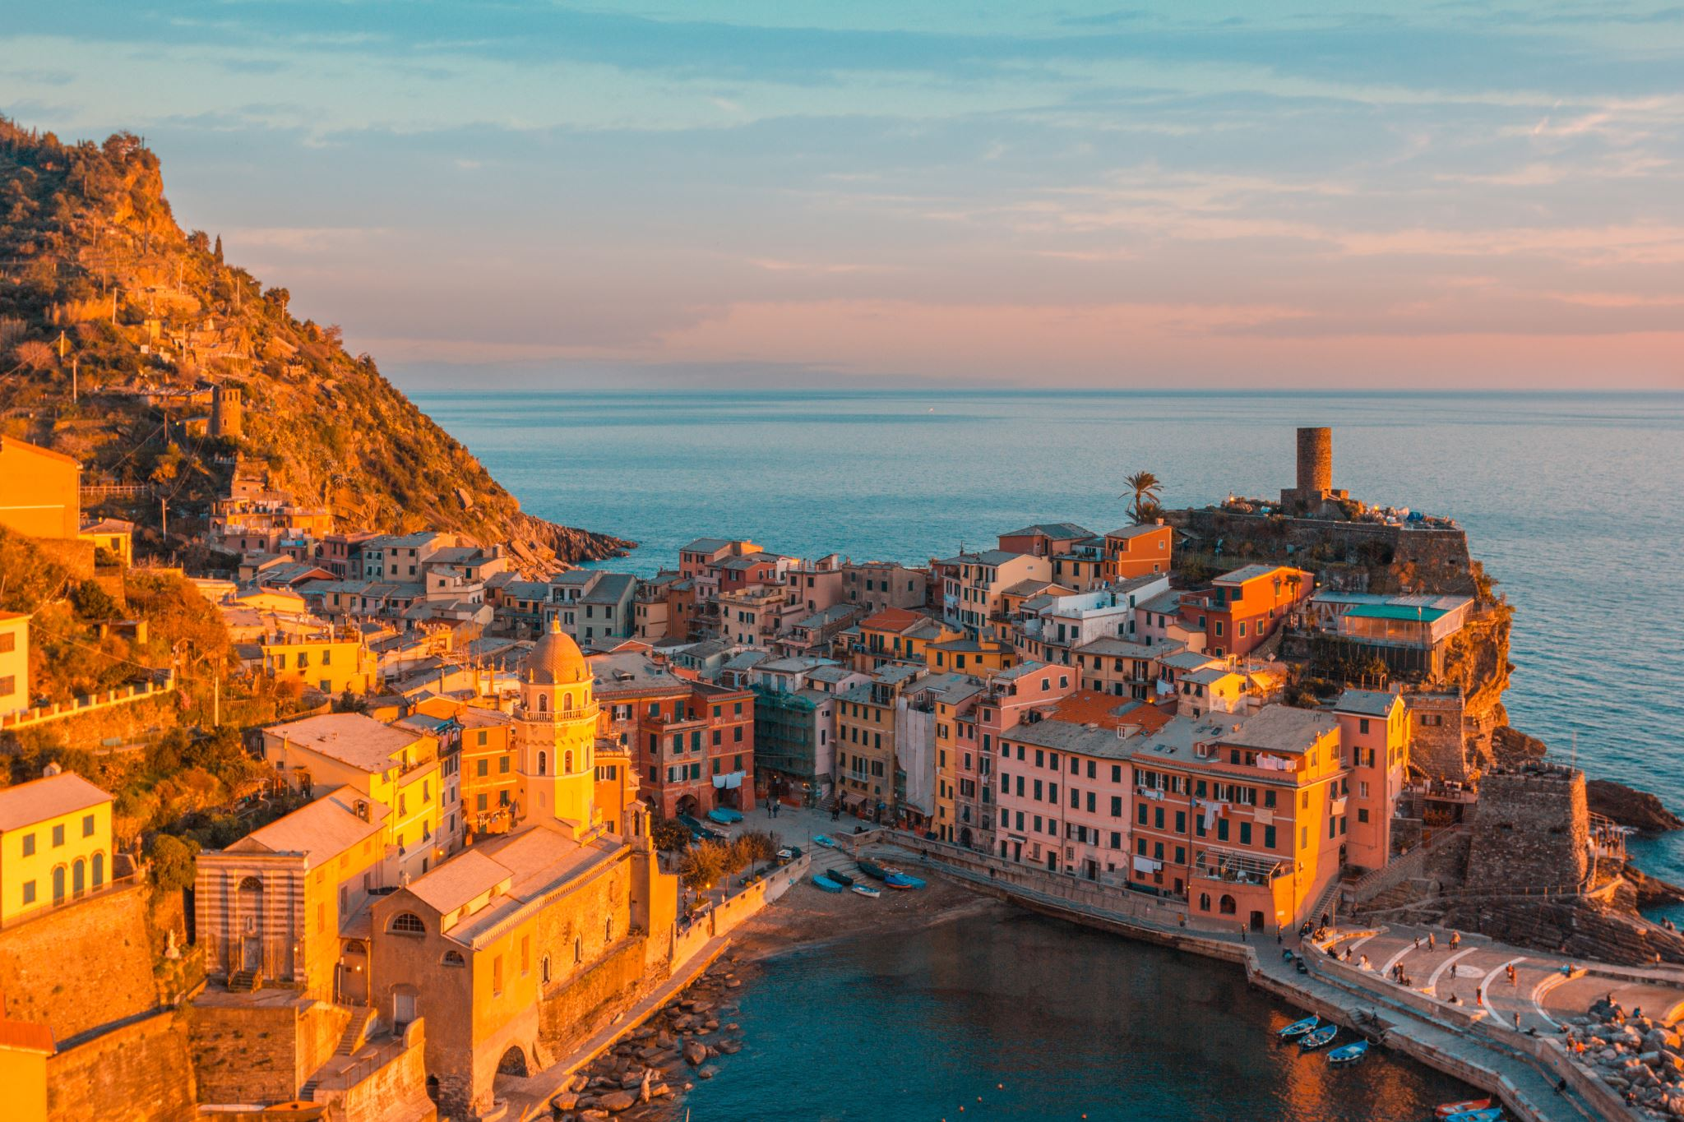

ASSUMPTIONS

1. No Unusual Occurrences (Outliers) between 2015 and 2017 will have a substantial impact on the Data used.
2. The Information is still current and can be used to analyze possible plans.
3. The Hotels are not currently using any of the suggested solutions.
4. The Biggest factor affecting effectiveness of earning income is booking Cancellations.
5. Cancellations result in vacant rooms for that length of time.
6. Clients make hotel Reservations the same year they make cancellations

RESEARCH QUESTIONS

1. What are the variables that affect Hotel Reservation cancellations?
2. How can we make Hotel Reservations cancellation better?
3. How will Hotels be assisted in making pricing and promotional decisions?

Hypothesis

1. More cancellations occur when prices are higher.
2. When there is longer waiting list , guests tend to cancel their reservations more frequently.
3. The majority of the clients are coming from offline travel agents to make their reservations.

Analysis and Findings

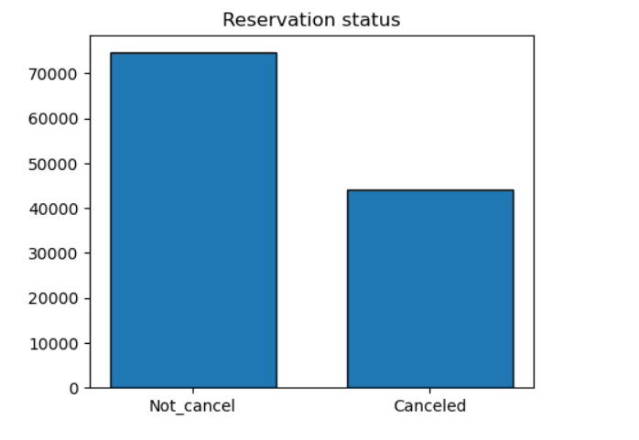

The accompany bar graph shows the percentage of reservations that are cancel and those that are not. It is obvious there are still a significant number of reservations that have not been cancelled but there are still 37% of clients cancel their reservation which has a significant impact on the hotel earnings.

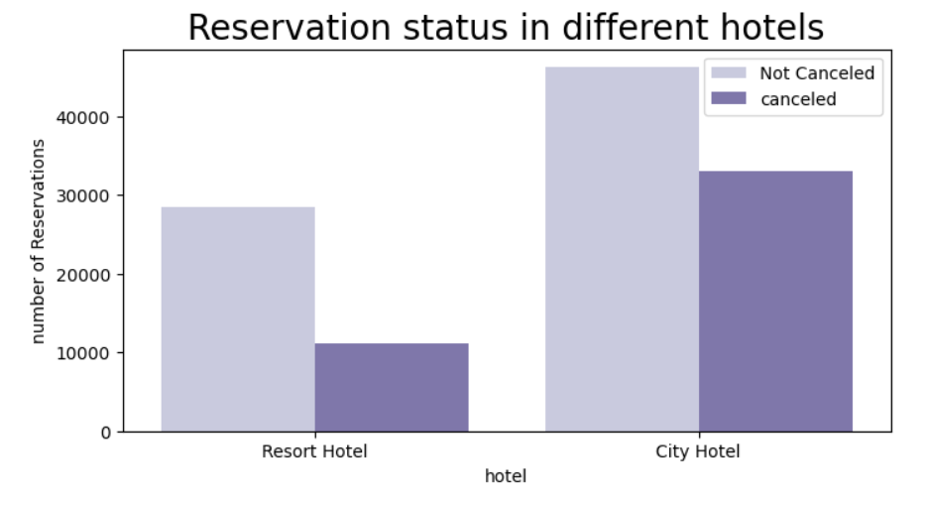

In comparison to resort hotels city hotels have more booking it is possible that resort hotels are more expensive then those and cities.

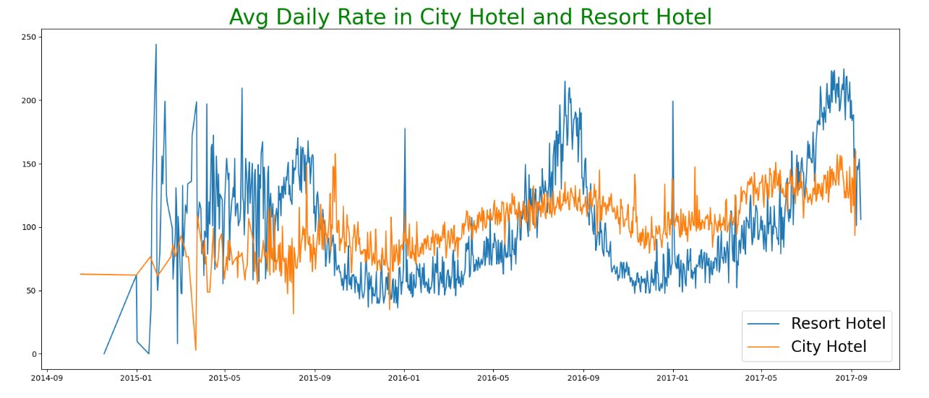

The line graph above shows that at uncertain days the average daily rate for city hotel is less than that of a Resort hotel and on other days it is even less. It goes without saying that weekends and holidays may see arrives in resort Hotel rates.

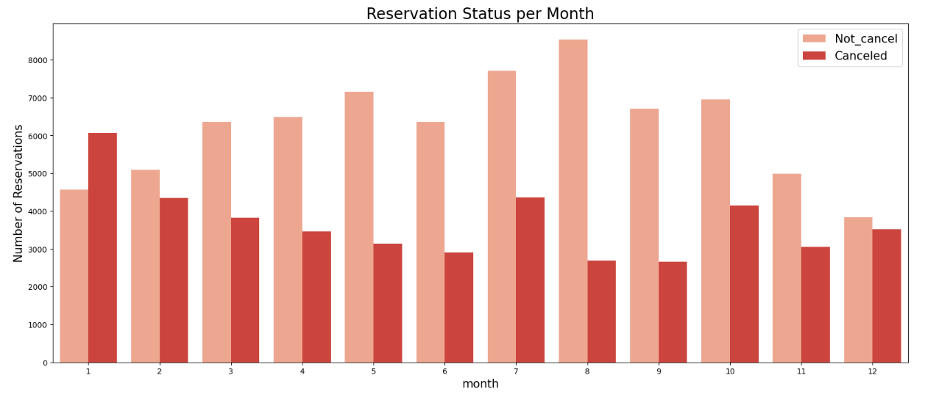

We have developed the group bar graph to analyse the months with the highest and lowest reservation levels according to reservation status as can be seen both the number of confirmed reservations and the number of cancelled reservations are largest in the month of August where is January is the month with most cancel reservation.

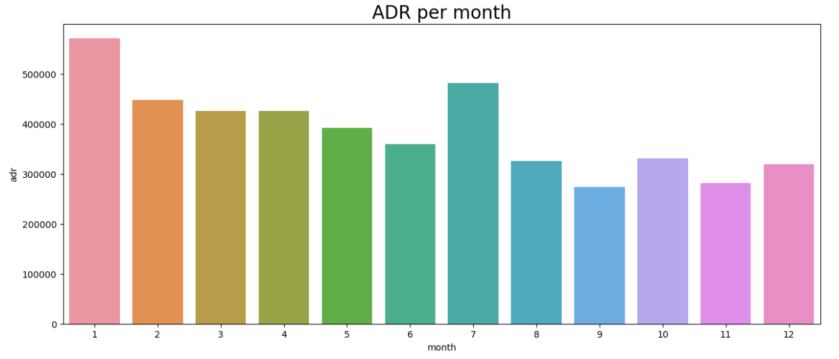

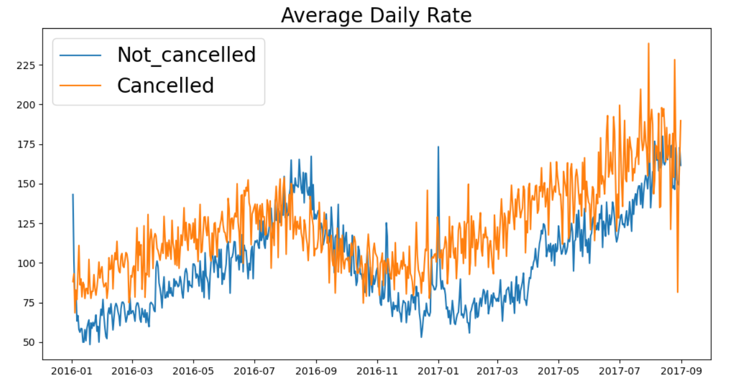

The this bar graph demonstrate that cancellations are most common and prices are greater and are at least common when they are lowest their cost of accommodation is only responsible for the cancellation

Now let's see which country has highest reservation cancelled the top country is Portugal with the highest number of cancellations. 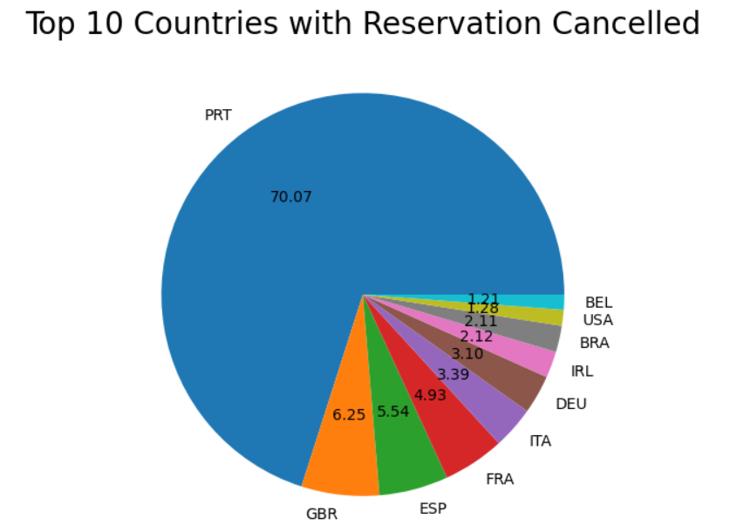

Let’s check the area from where guest visiting the hotels and book reservations, is it coming from direct or groups, online or offline travel agents .around 46% of the clients came from online travel agencies where as 27% come from groups only 4% of clients book hotels directly by visiting them and making reservation.

As seen in the graph reservation are cancelled when the average daily rate is higher then when it is not cancelled it clearly proves all the above analysis that the higher price leads to higher cancellation

Suggestions

1. Cancellation rate rises as a price does in order to prevent cancellation of reservations . Hotels could work on there pricing Strategies and try to lower the rates for specific Hotel based on locations then also provide some discounts to the guests.
2. As the ratio of cancellation not cancellation of the Resort hotel is higher in the Resort hotel then the city hotels so the hotels should per reasonable discount on the room prices on weekends or on holidays
3. In the Month of January hotels can start marketing campaigns or advertisement with reasonable amount to increase the revenue as the cancellation for the month of January is highest.
4. They can also increase the quality of their hotels and their services especially for countries like Portugal to reduce the cancellation rate